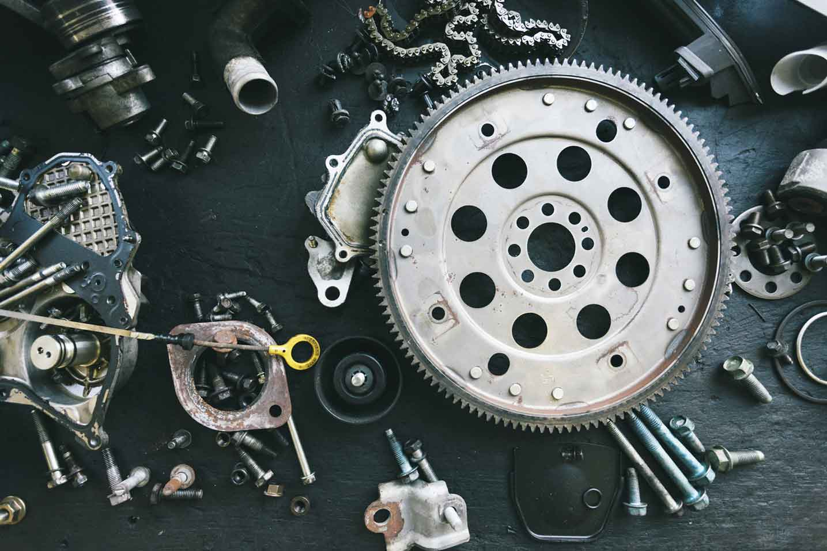­­­­­

|  |  |
| --- | --- |
|  |  |



Process Definition

Document

YouTube

Automation

Suite

Table of Contents

I. INTRODUCTION 4

1.1 Purpose 4

1.2 Objectives 4

1.3 Key Contacts 4

1.4 Minimum Pre-requisites for the Automation 4

II. AS IS Process description 5

2.1 Process Overview 5

2.2 Applications Used 6

2.3 AS IS Process Map 7

2.3.1 High Level Process Map 7

2.3.2 Detailed Level Process Map 7

2.4 Process Statistics 7

2.5 Detailed As Is Process Actions 8

2.6 Input Data Description 8

III. TO BE Process description 9

3.1. Detailed TO BE Process Map 9

3.2. Parallel Initiatives 9

3.3. In Scope For RPA 9

3.4. Out Of Scope for RPA 10

3.5. Exceptions Handling 10

3.5.1. Known Business Exceptions 10

3.5.2 Unknown Business Exceptions 10

3.6. Applications Errors & Exceptions Handling 11

3.6.1. Known Applications Errors and Exceptions 11

3.6.2. Unknown Applications Errors and Exceptions 11

3.7. Reporting 11

IV. Other 12

4.1. Additional sources of process documentation 12

# INTRODUCTION



## Purpose

YouTube is a vast online video library that offers virtually unlimited free content. However, keeping track of the videos you want to watch can be challenging, and using playlists to track videos is somewhat limited with YouTube's current playlist management options. The solution is the YouTube Automation Suite (YAS). YAS will allow you to manage your YouTube playlists automatically using the automation power of UiPath combined with Azure SQL Server to store user data and lower the costs of API calls to YouTube. YAS can also provide email updates for each video using Google integration.

## Objectives

The business objectives and benefits expected by the Business Process Owner after automation of the selected business process are:

* Provide a means of managing playlists outside of the YouTube website.
* Keep track of playlists and videos in a SQL database.

## Key Contacts

Add here any stakeholders that need to be informed or to approve changes to the process:

|  |  |  |  |
| --- | --- | --- | --- |
| Role | Name | Contact Details (email, phone number) | Notes |
| RPA Developer | Gavin Gilbert | gavin157@revature.net |  |
| RPA Developer | Irving Gonzalez Islas | irving814@revature.net |  |
| RPA Developer | Justin Quach | Justin345@revature.net |  |

## Minimum Pre-requisites for the Automation

1. UiPath Studio 2023.4.0
2. Microsoft Edge

# AS IS Process description

In this section the Business Analyst will document the process. This section will serve as the starting point for the re-engineering and automation effort.



## Process Overview

Section contains general information about the process before automation.

|  |  |
| --- | --- |
| Item | Description/Answer |
| Process Full Name | YouTube Playlist Management |
| Process Area | Entertainment |
| Department | YouTube Playlist Automation Solutions |
| Short Description (operation, activity, outcome) | Uses a menu to select an activity to execute and uses the YouTube API to execute those actions |
| Process schedule and frequency | User activated |
| Input data description | A menu containing valid activities for a playlist |
| Output Data description | Edits made to selected playlist and emails regarding any changes made to playlists. |

*Add more rows to the table to include relevant data for the automation process. No fields should be left empty. Use “n/a” for the items that don`t apply to the selected business process.

## Applications Used

The table includes a comprehensive list of all the applications that are used as part of the process to be automated to perform the given actions in the flow.

|  |  |  |  |  |  |
| --- | --- | --- | --- | --- | --- |
| Application Name | Version | Application Language | Thin/Think Client | Environment/ Access method | Comments |
| UiPath Studio | 2023.4.0 | VB .NET |  | UiPath Orchestrator |  |
| Microsoft Edge | 111.0.1661.54 | C++ |  | Ui Automation |  |
| YouTube Data API | v3 | VB .NET |  | HTTP Request |  |

*Add more rows to the table to include the complete list of applications.

## AS IS Process Map

This section contains various process maps contributing to a better understanding of how the process is performed pre-automation.

### High Level Process Map

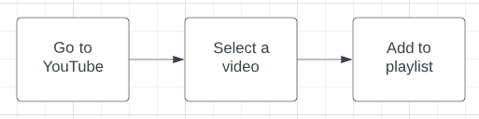

### Detailed Level Process Map

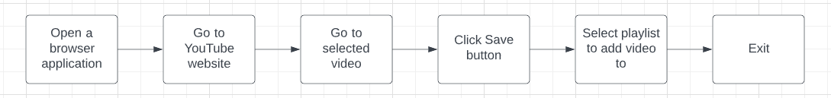

## Detailed As Is Process Actions

|  |  |  |  |  |  |
| --- | --- | --- | --- | --- | --- |
| #Action | Input | Description | Details (Screen/Video Recording Index) | Exceptions Handling | Possible Actions |
| N/A | N/A | N/A | N/A | N/A | N/A |

# TO BE Process description

In this section the proposed improvements to the process, actions to the process will be outlined as well as the actions proposed for automation and the type of robot required. **This will be cross-checked by the Solution Architect.**

## Detailed TO BE Process Map

A detailed process map of the process as it will look like post-automation will be outlined here.  
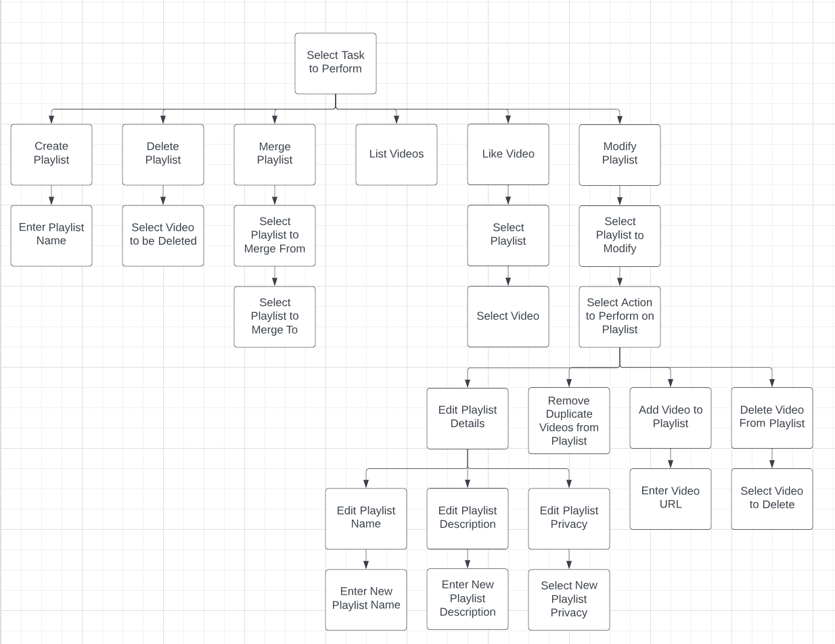  
*Highlight Bot interventions/ To-Be automated actions with different legend/ icon (purple).  
Mention below if process improvements were performed on the To-Be design and provide details.*

|  |  |
| --- | --- |
| Legend | Description |
|  | Action number in the process. Referred to in details or Exceptions and Errors table. |
|  | This process action is proposed for automation. |
|  | This process action remains manual (to be performed by a human agent). |

## Exceptions Handling

The Business Process Owner and Business Analysts are expected to document below all the business exceptions identified in the automation process. Exceptions are of 2 types and both need to be addressed:

**Known exceptions** = previously encountered. A scenario is defined with clear actions and workarounds for each case.

**Unknown** = New situation that was not encountered before. It cannot be predicted and in case it happens it needs to be flagged and communicated to an authorized person for evaluation.

### Known Business Exceptions

Details regarding how the robot should handle the exceptions.

|  |  |  |  |
| --- | --- | --- | --- |
| Exception Name | Action | Parameters | Action to be taken |
| *OAuth Token is Empty* | *Variable* | *OAuth Token* | *Retry getting OAuth token* |
| *HTTPS Check* | *HTTP Request* | *HTTPS Status Code* | *Send email to admin w/ response code & content* |

### 3.5.2 Unknown Business Exceptions

An umbrella rule that includes a notification needs to be designed for all other exceptions that could happen and cannot be anticipated.

All other cases should be resolved by contacting the system administrator at: yas.p2.project@gmail.com

## Applications Errors & Exceptions Handling

A comprehensive list of all errors, warnings or notifications should be consolidated here together with the action to be taken for each by the Robot. There are 2 types of exceptions/errors:

**Known** = Previously encountered and action plan or workaround available for it (e.g. SAP unresponsive during peak times)

**Unknown** = these are exceptions and errors that cannot be anticipated but for which the robot needs to have a rule so that the RPA solution is sustainable.

### Known Applications Errors and Exceptions

Details regarding how the robot should handle the exceptions.

|  |  |  |  |
| --- | --- | --- | --- |
| Error/Exception Name | Action | Parameters | Action to be taken |
| *OAuth Error* | *Get Text* |  | *Send email to admin* |
| *HTTPS Check* | *HTTP Request* | *HTTPS Status Code* | *Send email to admin w/ response code & content* |

### Unknown Applications Errors and Exceptions

An umbrella rule that includes a notification needs to be designed for all other exceptions that could happen and cannot be anticipated.

*Robot will attempt twice before stopping all processes.*

## Reporting

In this section all the reporting requirements of the business should be detailed so that when the RPA solution is moved to production the administrators can track the performance of the solution.

|  |  |  |  |
| --- | --- | --- | --- |
| Report Type | Update frequency | Details | Monitoring Tool to visualize the data |
| *Data Tables* | *Every other hour* | *Data on all playlists and videos in those playlists* | *Microsoft Azure* |

* For complex reporting requirements, include them into a separate document and attach it to the present documentation

# Other

## Additional sources of process documentation

If there is additional material created to support the process automation please mention it here, along with the supported documentation provided.

|  |  |  |
| --- | --- | --- |
| Additional Process Documentation | | |
| Video Recording of the process (Optional) | Acme-System1-Process-WI5-Manual-Walkthrough | Insert any relevant comments |
| Business Rules Library (Optional) | Insert link to Business rules library | Insert any relevant comments |
| Other documentation (Optional) | Insert link to any other relevant process documentation (L4, L5 process description, fields mapping files etc.) | Insert any relevant comments |
| Standard Operating Procedure(s) (Optional) |  | Insert any relevant comments |
| High Level Process Map (Optional) |  | Insert any relevant comments |
| Detailed level process map (Optional) |  | Insert any relevant comments |
| Work Instructions (Optional) |  | Insert any relevant comments |
| Input Files (Optional) |  | Insert any relevant comments |
| Output Files (Optional) |  | Insert any relevant comments |

*Add more rows to the table to reflect the complete documentation provided to support the RPA process.

